

Financial plan for the "Gundam-Shop" web application
Justin VILLEROT Bureautique S1-2021
Justin VILLEROTBureautique S1-2021
Justin VILLEROT Bureautiques S1-2021
Justin VILLEROT Bureautique S1-2021
S1 A1 2021
SAE S1-06
S1 2021
2022
VILLEROT Justin
VALENNE Nathan
WILCZAK Lilian
Group : 1

Content
1 Project data 4
1.1 Summary of the project 4
1.2 Summary of tasks to be performed 4
1.3 Synthesis 5
2 Data on the company 6
2.1 Company capacity 6
2.2 Costs 6
2.3 Summary 6
3 Priority of tasks 7
4 Additional costs 8
4.1 Reimbursement of licences 8
4.2 Server maintenance costs 8
5 Synthesis 9
5.1 Project costs 9
5.1.1 Development costs 9
5.1.2 Sustaining costs 9
5.1.3 Overview 10
5.2 Duration of the project 10

Project data

Summary of the project
The site aims to reach teenagers, young adults and adults. It aims to reach in particular the consumers of Japanese cultural products, in particular the worshippers of the Gundam license. The site is also aimed at model making enthusiasts.
For more information see the specifications.

Summary of tasks to be performed
As we can see in the following diagrams this project is composed of 16 tasks with a planned number of 29 man-hours. This number corresponds to what was expected at the beginning of the project, in real time we expect a 10-20%.
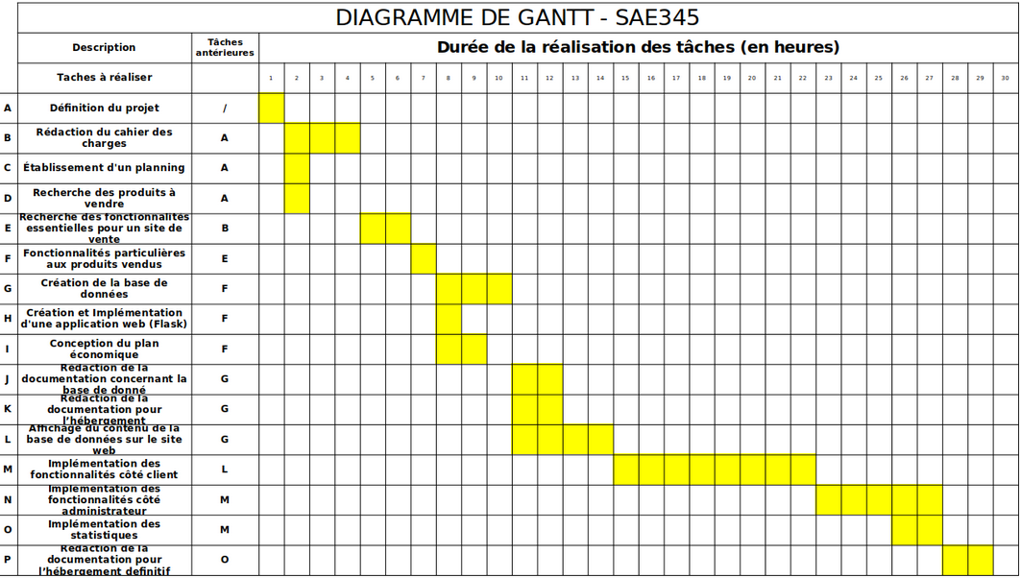Illustration 1: Gantt chart

Synthesis
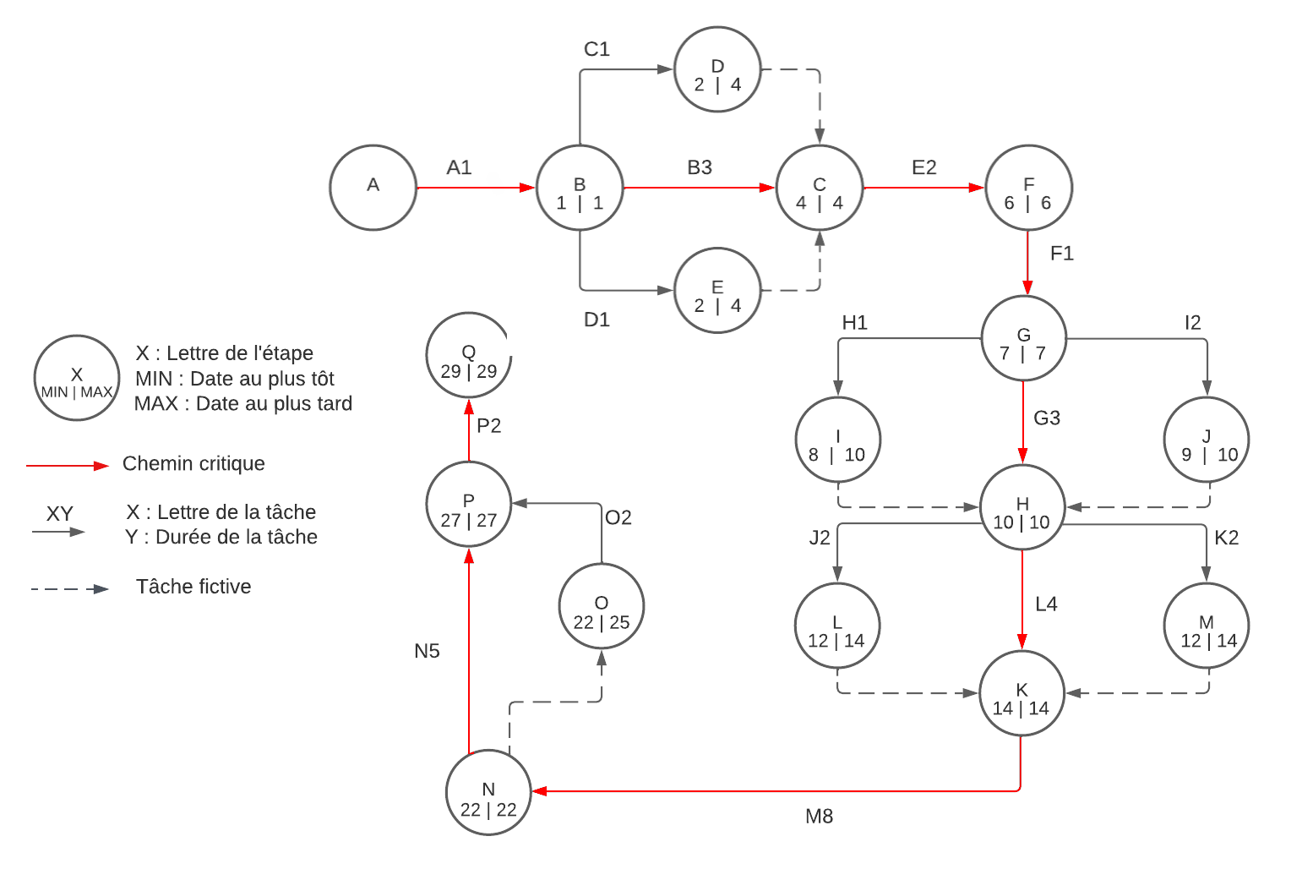Illustration 2: Pert diagram
- Number of tasks 16
- Expected number of man-hours 29
- Expected variation ± 5 to 20% of total time or ± 6 man-hours

Data on the company

Company capacity
The company taking over the project can provide three people. These three people will be paid for the hours they work, and any hours over and above what was planned will be paid for.

Costs
The company pays these employees 25€ per hour, all hours will be paid at the same hourly rate. In addition, each employee can only work on the project for 5 hours per week.
The company also offers a project completion bonus if the project has been delivered with the expected number of hours or less. This bonus corresponds to a 5% bonus on the hours worked.

Summary
Nbr hour  Illustration 3: Cost versus time chart | Costs
22 | 577,50€
23 | 603,75€
24 | 630,00€
25 | 656,25€
26 | 682,50€
27 | 708,75€
28 | 735,00€
29 | 761,25€
30 | 750,00€
31 | 775,00€
32 | 800,00€
33 | 825,00€
34 | 850,00€
35 | 875,00€
36 | 900,00€
- Number of people: 3 to 5 hours per week
- Cost per hour: 25€/hour

Priority of tasks
Illustration 4: Pert diagram
As we can see in the above disturbance diagram some tasks have a certain amount of time available while others would delay the whole project if they were to fall behind.
These tasks are part of the critical path, which is represented by the red arrows. A summary in the form of a table is also available below.
Tasks | A | B | C | D | E | F | G | H | I | J | K | L | M | N | O | P | Q
Is critical

The critical tasks will therefore be prioritised as the slightest delay on these tasks will influence the whole project.

Additional costs

Reimbursement of licences
The project requires a number of external software or service licenses, so we charge a portion of the cost of these licenses that corresponds to 10% of the annual license fee for projects that last less than one semester. The licenses we charge for this project are as follows:
- JetBrains licence 40€/employee (Development software)
- PythonAnywhere 50€ (Hosting of the site during development)
- Github entreprise 25€ (Management of the files corresponding to the project)

Server maintenance costs
In addition to the cost of the licences, there is the cost of hosting the servers as well as maintenance in case of problems or the need for updates.
For the cost of hosting see report 1_choix.pdf attached. And for the security certificate of the servers see the report 1_besoins.pdf attached. Finally, for maintenance and updates the rates are summarized in the table below.
Name | Description | Costs
Monthly costs | Costs of maintaining the service | 20€
Updating certificates | Updating and installing new certificates | 200€
Update of the hosting system | Updating the software hosting the site | 100€
Change of host | Moving the site to a new machine or expanding storage | 400€
Graphic modification | Change of the graphic aspect of the site | 200€ + manpower
Modification of the site | Adding/modifying site functionality | Quote required
An update of the hosting system and certificates is expected every year.

Synthesis

Project costs
The costs of this project are divided into two major parts. The first is the development costs of the website, which will include all the activities before the website goes live. Secondly, there are maintenance costs, which include everything that happens after the initial development phase, and which will be there for the life of the website.

Development costs
To measure the expected cost of project development, two types of expenditure must be taken into account:
- The fixed expenses include the reimbursement of the licenses, as well as the initial installation of the website.
- The variable expenses are mainly composed of the labour costs as well as the costs of various modifications that will be made to the initial project during the development.

Sustaining costs
Maintenance costs include everything that will be required to maintain the website once development is complete. This includes the cost of maintenance, the cost of future interventions and the hosting of the site.
As part of the maintenance costs, an annual update of the hosting system and the website certificates is planned. The purpose of this update is to guarantee the security of the website. Indeed, software that is not regularly updated can have security holes, compromising the integrity of the website. This is why an annual update is recommended as a strict minimum. However, more regular updates are possible.
For more details see server maintenance costs above.

Overview
Name | Description | Cost min | Expected cost | Cost max
Licences | Reimbursement of licences | 115€
Site installation | Initial setup of the site and installation on the server | 400€
Manpower | Employee salaries and project completion bonuses | 577,50€ | 761,25€ | 900€
Unforeseen | Addition of new functionality or modification of the project | New quote
Monthly costs | Costs of maintaining the service | 20€/month
Intervention | See server maintenance costs | 0€ | 300€/ans | 300€/year + Quote
Total |  | 1092.50€ + 20€/month | 1276.25€  +  320€/year | 1415€  +  320€/year  +  quote required

Duration of the project
Knowing that the company can provide 3 employees who can each work 5 hours per week on the project, and that the project can last 22 to 36 hours with a planned duration of 29 hours.
We can therefore deduce that the development phase of the project will last between 2 and 3 weeks.

Index des Illustrations
Illustration 1: Gantt chart 4
Illustration 2: Pert diagram 5
Illustration 3: Cost versus time chart 6
Illustration 4: Pert diagram 7

